**AIM**:

FLAMES is a popular game named after the acronym: friends, lovers, affectionate, marriage, enemies, and siblings. This game does not predict whether an individual is right for you. There are few steps in the game

1) Take two names on which you wanna perform flames.

2) Remove the common characters from both the names.

3) Get the remaining characters and add them to a variable called count

4) Take a character array for F, L, A, M, E, S

5) Start removing letters from F, L, A, M, E, S using the count we got.

6) the letter that will be left at last using the count is the result

**1. Problem Statement:**

To develop a Python program that accurately implements the FLAMES game logic, allowing users to input two names and determine their predicted relationship based on the established game rules.

**Game Rules:-**

**Input:**

Two player names: player1 and player2.

**Process:**

* Convert both names to lowercase.
* Remove common letters from both names.
* Count the remaining letters and store it in a variable count.
* Create a string flames with the letters "FLAMES".
* While the length of flames is greater than 1:
* Calculate the index to remove based on count and the length of flames.
* Remove the character at the calculated index from flames.
* The final remaining letter in flames represents the relationship status.

**Output:**

The relationship status as a string (F for Friends, L for Lovers, A for Affectionate, M for Marriage, E for Enemies, S for Siblings).

**2. Algorithm:**

* **Start**
* Input player1 and player2 names.
* Convert both names to lowercase.
* Remove common letters from both names.
* Count remaining letters and store in count.
* Initialize flames string.
* While flames length is greater than 1:
* Calculate index to remove.
* Remove character at index from flames.
* Output the final remaining letter in flames as the relationship status.
* **End**

**3. Pseudocode:**

function **FLAMES**(name1, name2):

**convert name1 and name2 to lowercase**

for each character in name1:

if character is in name2:

remove first occurrence of character from name1

remove first occurrence of character from name2

count = length of name1 + length of name2

**flames_list**=["Friends", "Lovers", "Affectionate", "Marriage", "Enemies","Siblings"]

while length of flames_list is greater than 1:

index = (count - 1) modulo length of flames_list

remove element at index from flames_list

count = (count - 1) divided by length of flames_list **(integer division)**

**return the only remaining element in flames_list**

**4. Implementation[code]:**

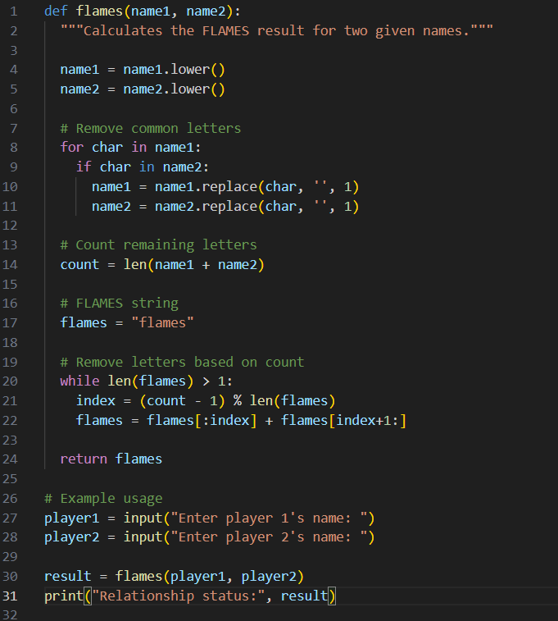

**Output:**

